

Solution Architecture

Date | 25 June 2026
Team ID | xxxxxx
Project Name | Solution Architecture
Maximum Marks | 5 Marks

Solution Architecture Diagram:
The architecture ensures efficient data flow, secure processing, accurate loan eligibility prediction, and seamless communication between all system modules.
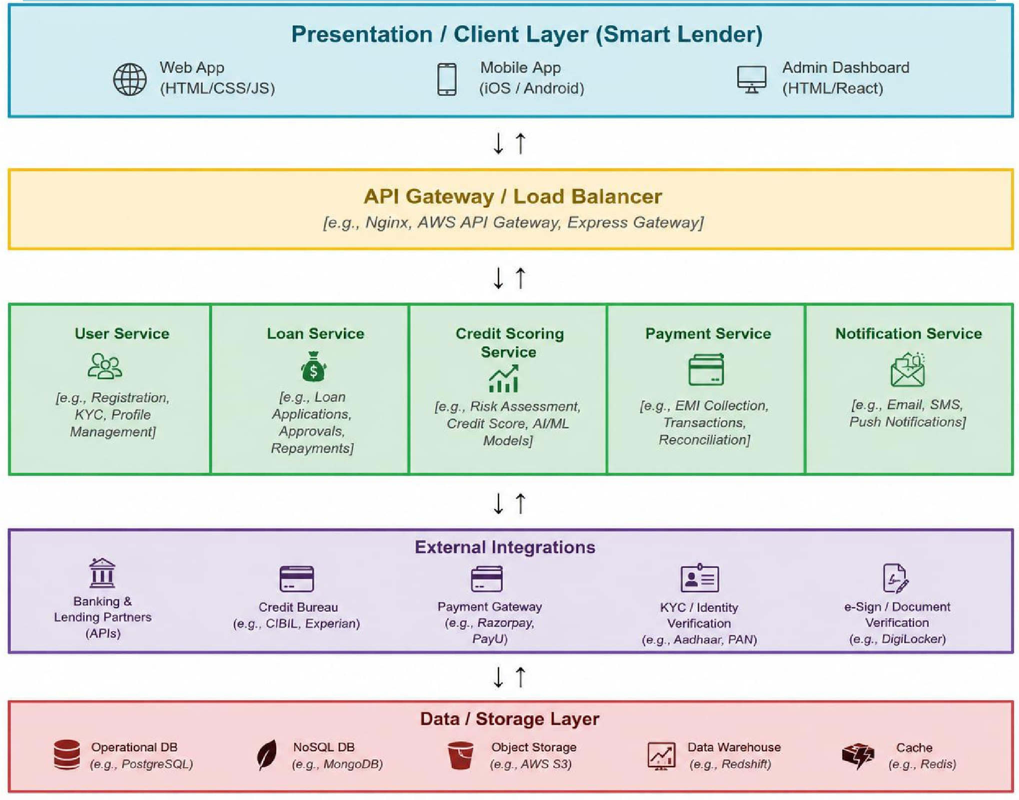



Component Description Table

Component Name | Description / Role in Architecture | Technologies Used
Presentation Layer | Provides user interface for registration, login, loan application, and prediction result display. | HTML, CSS,  Bootstrap,  JavaScript
Application Layer | Handles HTTP requests, manages routing, validates user input, and communicates with the ML model. | Python, Flask
Core Logic Service | Processes applicant information and predicts loan eligibility using a trained Machine Learning model. | Scikit-learn, Pandas,  NumPy, Joblib
Database / Storage  Layer | Stores user information, trained model, and prediction history. | SQLite, CSV Dataset

